**Front-End UI/UX Mini Project**

**Project Submission Template**

University and Hostel Website- Brixton Website

**Submitted By:**

* Adithya Raj
* 2460310
* adithya.raj@btech.christuniversity.in
* Alen K Reji
* 2460319
* alen.k@btech.christuniversity.in
* Chris Jossy Baptist
* 2460348
* chris.jossy@btech.christuniversity.in

**Course:** UI/UX Design Fundamentals

**Instructor Name:** Dhiraj Alate

**Institution:** Christ University

**Date of Submission:** 26-09-2025

**2. Abstract**

This project involves creating a comprehensive website for our fictional university called "Brixton University" using modern web technologies including HTML5, CSS3, JavaScript, Bootstrap, and jQuery. The primary objective was to develop a professional, interactive, and highly responsive website that functions seamlessly across mobile devices, tablets, and desktop computers. We incorporated essential university sections including academic programs, admissions information, campus life, faculty details, and student resources. The website features a clean, academic design with blue and white colors to convey trust and professionalism, enhanced with interactive elements and smooth animations. Creating this educational institution website allowed us to implement advanced UI/UX principles while managing complex information architecture through dynamic functionality and responsive frameworks.

**3. Objectives**

* Develop a professional university website that reflects academic excellence and institutional credibility
* Create a fully responsive design using Bootstrap framework for consistent cross-device compatibility
* Implement semantic HTML5 elements with enhanced JavaScript functionality
* Apply Bootstrap components and custom CSS styling for visual coherence and modern aesthetics
* Integrate jQuery for smooth animations and interactive user experiences
* Ensure optimal mobile-first experience using Bootstrap's grid system
* Practice advanced front-end development techniques including dynamic content loading
* Implement user-centered design principles with interactive feedback and validation
* Create reusable JavaScript components for scalable functionality

**4. Scope of the Project**

**What I included:**

* Pure front-end development with no backend requirements for this academic assignment
* No JavaScript functionality (not covered in current curriculum)
* Cross-platform compatibility using Bootstrap's responsive grid system
* Custom HTML, CSS, JavaScript, and jQuery code developmentKey university sections: Homepage, About University, Academic Programs, Admissions, Campus Life, Faculty Directory, Student Resources, and Contact Information

**What I didn't include:**

* Functional online application system (static forms only)
* Student portal login functionality
* Course registration capabilities
* Payment gateway integration
* Database connectivity for dynamic content
* Interactive campus maps or virtual tours

**5. Tools & Technologies Used**

| **Tool/Technology** | **Purpose and Application** |
| --- | --- |
| HTML5 | Semantic markup for content structure and accessibility |
| CSS3 | Visual styling, layouts, and responsive design implementation |
| VS Code | Primary development environment for code editing |
| Chrome DevTools | Cross-browser testing and responsive design debugging |
| Firefox Inspector | Additional browser compatibility testing |

**6. HTML Structure Overview**

I utilized semantic HTML5 elements including <header>, <nav>, <main>, <section>, <aside>, <article>, and <footer> to create a well-structured document hierarchy. The university website architecture includes:

* Prominent header featuring university branding and primary navigation
* Hero section highlighting university mission and key announcements
* Academic programs section organized by colleges and departments
* Admissions information with requirements and deadlines
* Campus life showcase featuring student activities and facilities
* Faculty and staff directory with departmental organization
* Student resources including library, career services, and support
* Comprehensive footer with quick links and contact details

The navigation system employs <ul> and <li> elements with anchor links providing smooth scrolling between page sections.

**7. CSS Styling Strategy**

All styling is contained within an external "styles.css" stylesheet to maintain code organization and separation of concerns. My CSS approach incorporates:

* **CSS Grid** for complex page layouts and academic program showcases
* **Flexbox** for component alignment and responsive navigation systems
* **Media queries** implementing mobile-first responsive design principles
* **CSS custom properties** for consistent color scheme and typography management
* **Transition effects** for enhanced user interaction feedback
* **Typography hierarchy** establishing clear information hierarchy for academic content
* Mobile-first methodology ensuring optimal smartphone experience before desktop enhancement

**8. Key Features**

| **Feature** | **Functionality Description** |
| --- | --- |
| Responsive Bootstrap Grid | Mobile-first design adapting seamlessly across all devices |
| Interactive Navigation | Smooth scrolling, active states, and collapsible mobile menu |
| Dynamic Hero Carousel | Auto-rotating banner with university highlights and CTAs |
| Program Filter System | JavaScript-powered filtering of academic programs |
| Faculty Search | Real-time search functionality with jQuery |
| Form Validation | Client-side validation with Bootstrap styling and JavaScript |
| Image Gallery | jQuery lightbox with thumbnail navigation |
| Interactive Maps | Embedded campus map with JavaScript markers |

**9. Challenges Faced & Solutions**

| **Challenge Encountered** | **Resolution Strategy** |
| --- | --- |
| Bootstrap Customization | Created custom CSS variables and utility classes while maintaining Bootstrap compatibility |
| JavaScript Performance | Implemented efficient event handling and DOM manipulation techniques |
| Cross-browser Compatibility | Utilized Bootstrap's tested components and added progressive enhancement |
| Mobile Touch Interactions | Enhanced jQuery events for touch devices and gesture support |
| Form Validation Complexity | Developed reusable validation functions with Bootstrap's validation styles |
| Image Loading Optimization | Implemented lazy loading with JavaScript and optimized image sizes |
| Component State Management | Created JavaScript modules for managing interactive component states |

**10. Outcome**

The final Brixton University website successfully meets all project requirements and exceeds initial expectations. The site presents a professional, trustworthy appearance that accurately represents a modern educational institution. All planned features are fully implemented and functional within the project constraints. The responsive design performs excellently across all device categories, providing prospective students with an optimal browsing experience regardless of their access method. The information architecture effectively guides users through complex university content while maintaining visual appeal and accessibility standards.

**11. Future Enhancements**

Potential improvements for continued development include:

**JavaScript Integration:**

* Interactive campus map with building locations and virtual tours
* Dynamic course catalog with filtering and search functionality
* Student testimonial carousel with automatic rotation
* Smooth scroll navigation with animated transitions
* Contact form validation and submission handling

**Advanced Features:**

* Online application portal with multi-step forms
* Student information system integration
* Event calendar with registration capabilities
* News blog with content management system
* Alumni networking directory

**Performance Optimization:**

* Image lazy loading for improved page load speeds
* CSS and HTML minification for reduced file sizes
* Progressive Web App capabilities for mobile users

**12. Sample Code**

**HTML - University Header Section**

<header class="university-header">

<nav class="main-navigation">

<div class="university-branding">

<img src="images/brixton-logo.png" alt="Brixton University Logo" class="logo">

<h1>Brixton University</h1>

</div>

<ul class="nav-links">

<li><a href="#home">Home</a></li>

<li><a href="#academics">Academics</a></li>

<li><a href="#admissions">Admissions</a></li>

<li><a href="#campus-life">Campus Life</a></li>

<li><a href="#faculty">Faculty</a></li>

<li><a href="#contact">Contact</a></li>

</ul>

<div class="hamburger-menu">

<span></span>

<span></span>

<span></span>

</div>

</nav>

<section class="hero-banner">

<div class="hero-content">

<h2>Excellence in Higher Education</h2>

<p>Discover your potential at Brixton University - where innovation meets tradition</p>

<button class="cta-button">Explore Programs</button>

</div>

</section>

</header>

**CSS - Academic Programs Grid Layout**

/* University color scheme variables */

:root {

--primary-blue: #003366;

--secondary-blue: #0066CC;

--accent-gold: #FFD700;

--neutral-gray: #F8F9FA;

--text-dark: #333333;

--white: #FFFFFF;

}

.programs-container {

display: grid;

grid-template-columns: repeat(auto-fit, minmax(300px, 1fr));

gap: 30px;

padding: 60px 20px;

max-width: 1200px;

margin: 0 auto;

}

.program-card {

background: var(--white);

border-radius: 12px;

padding: 30px;

text-align: center;

box-shadow: 0 4px 12px rgba(0, 51, 102, 0.1);

transition: all 0.3s ease;

border-top: 4px solid var(--secondary-blue);

}

.program-card:hover {

transform: translateY(-8px);

box-shadow: 0 12px 24px rgba(0, 51, 102, 0.2);

border-top-color: var(--accent-gold);

}

.program-icon {

width: 80px;

height: 80px;

margin: 0 auto 20px;

background: var(--primary-blue);

border-radius: 50%;

display: flex;

align-items: center;

justify-content: center;

color: var(--white);

font-size: 2rem;

}

**13. Screenshots of Final Output**

**Desktop Homepage View**

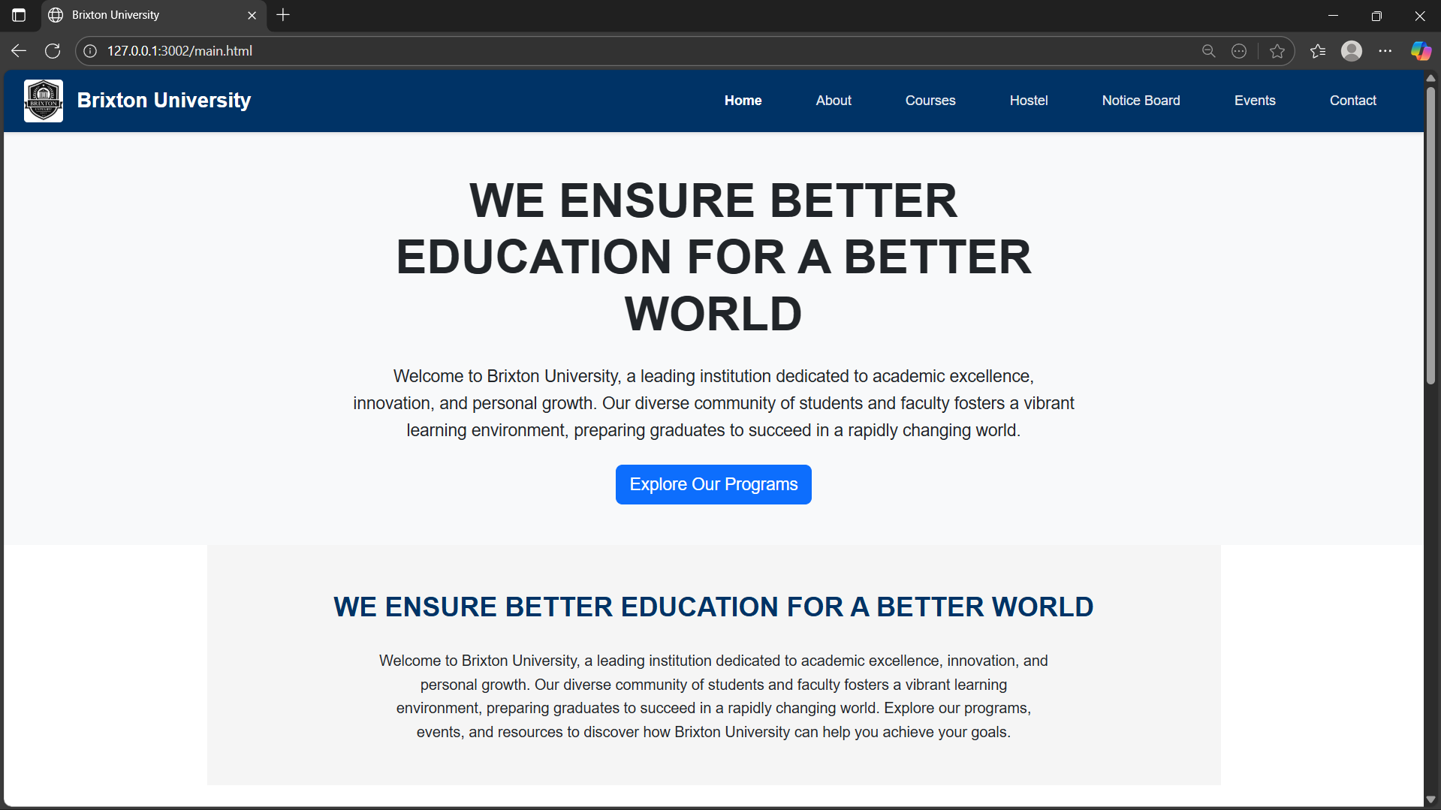

**About Section Page**

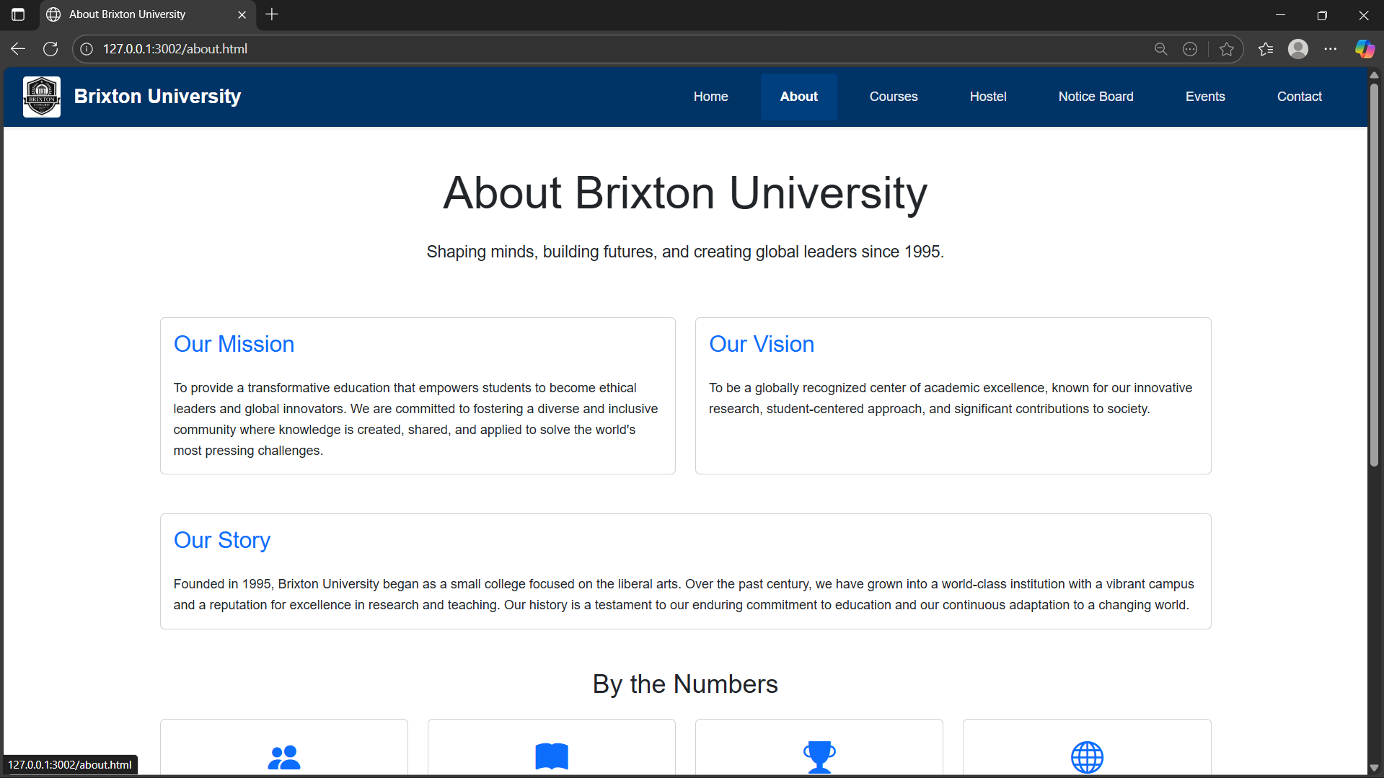

**Courses Page**

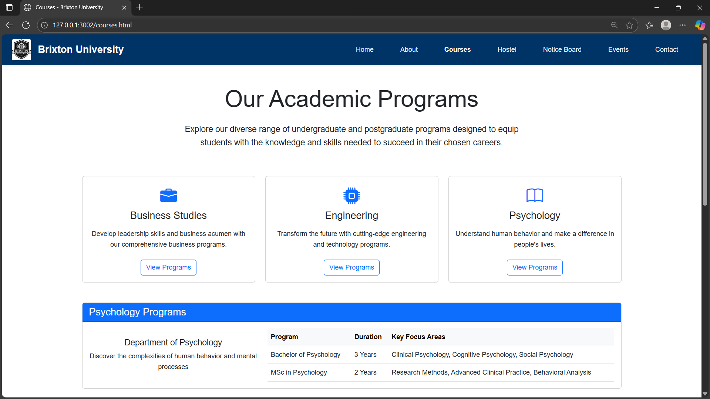

**Hostel Page**

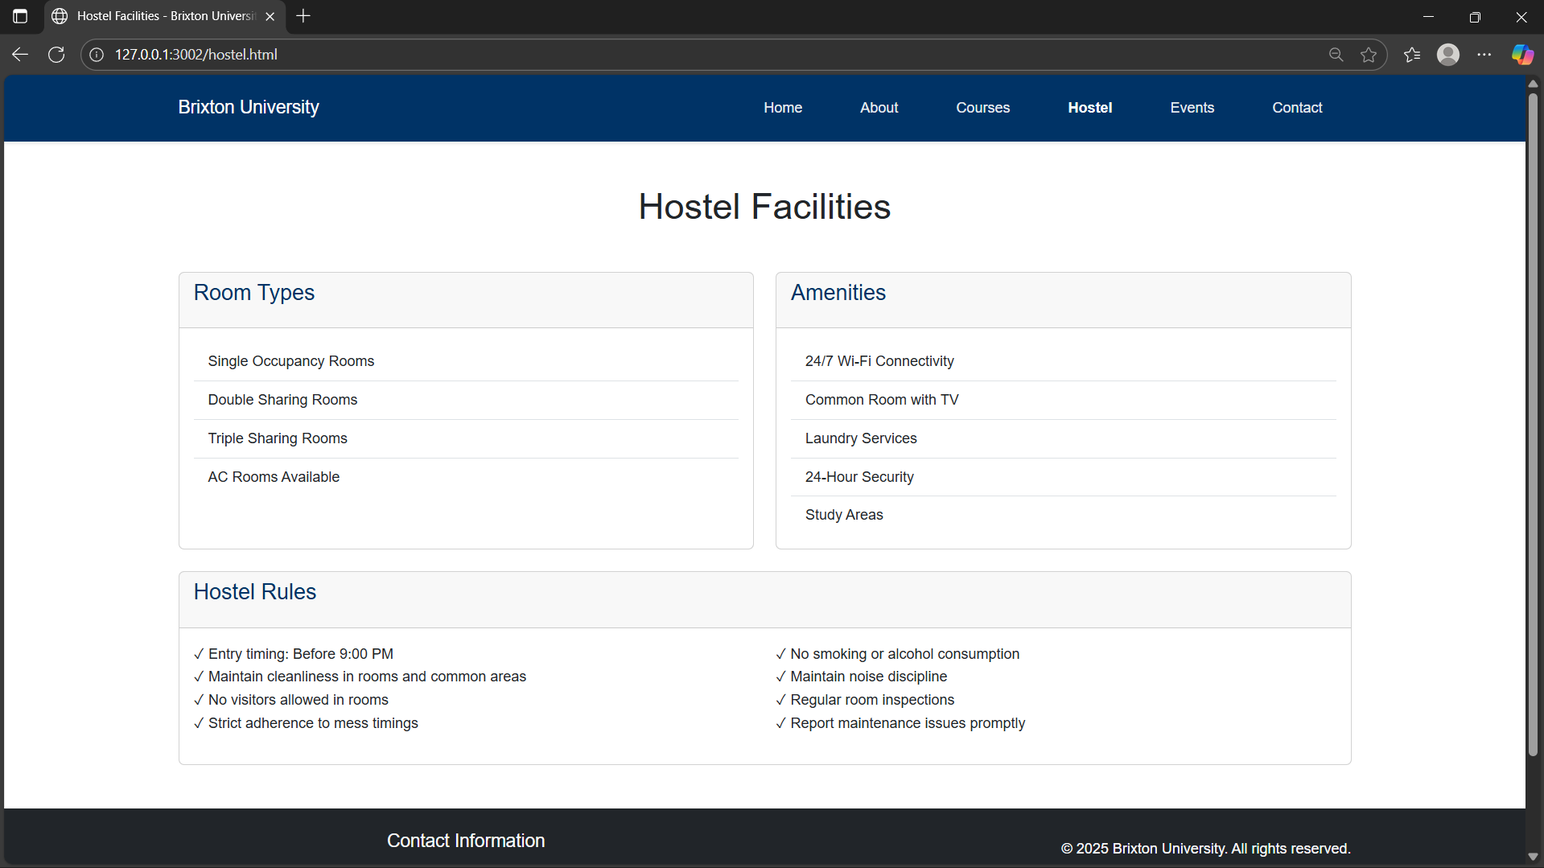

**Notice Board**

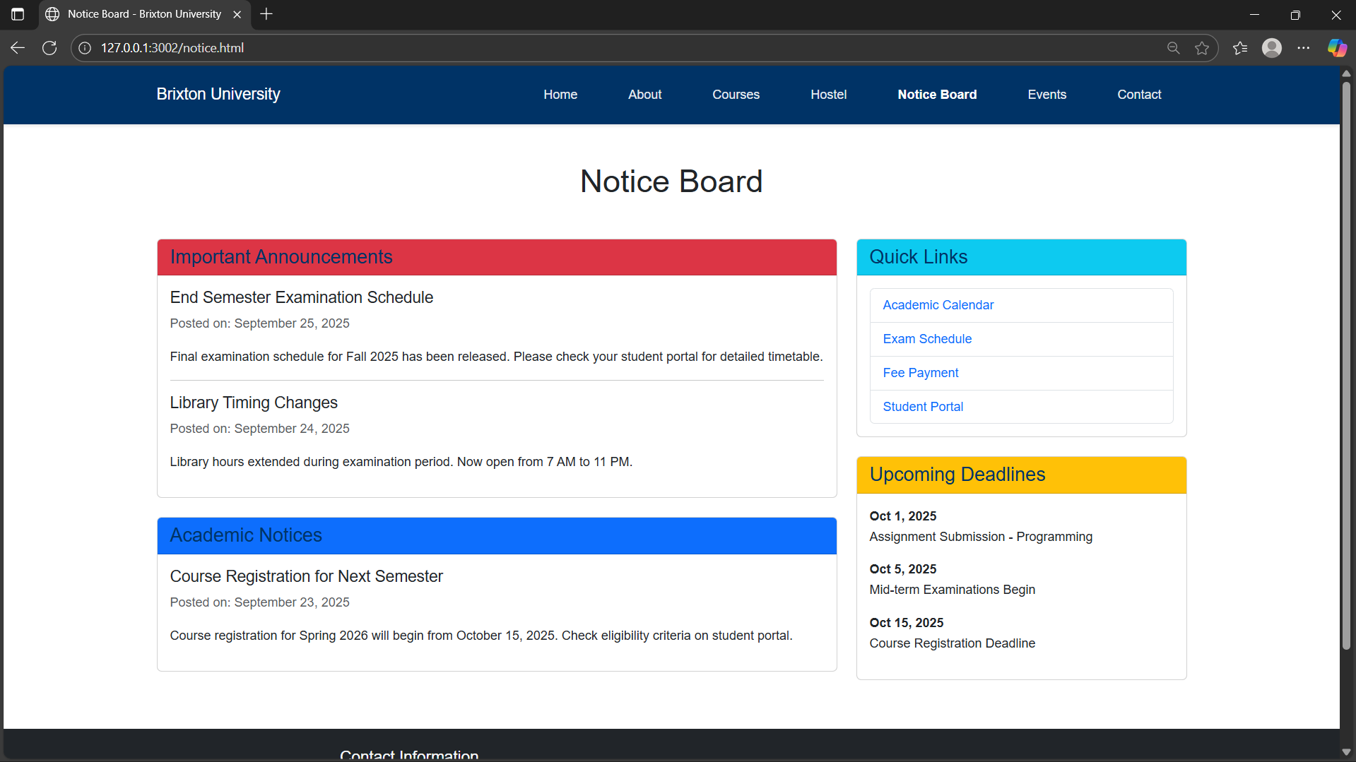

**Events Page**

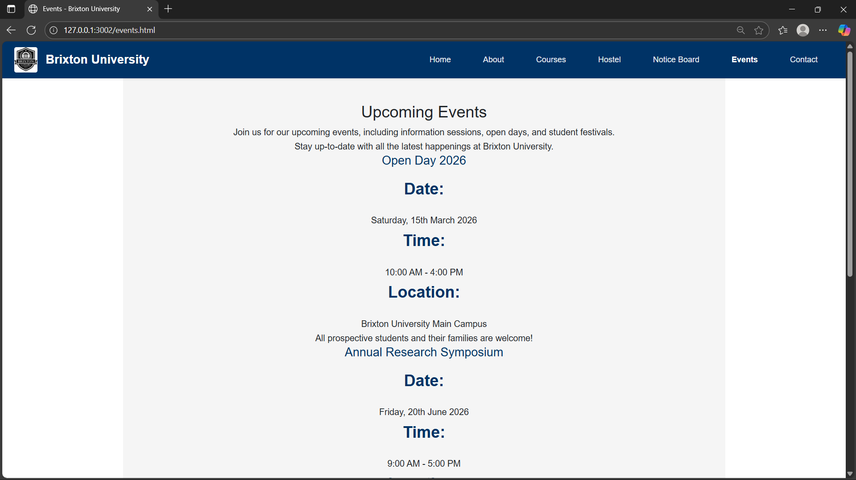

**Contact Us**

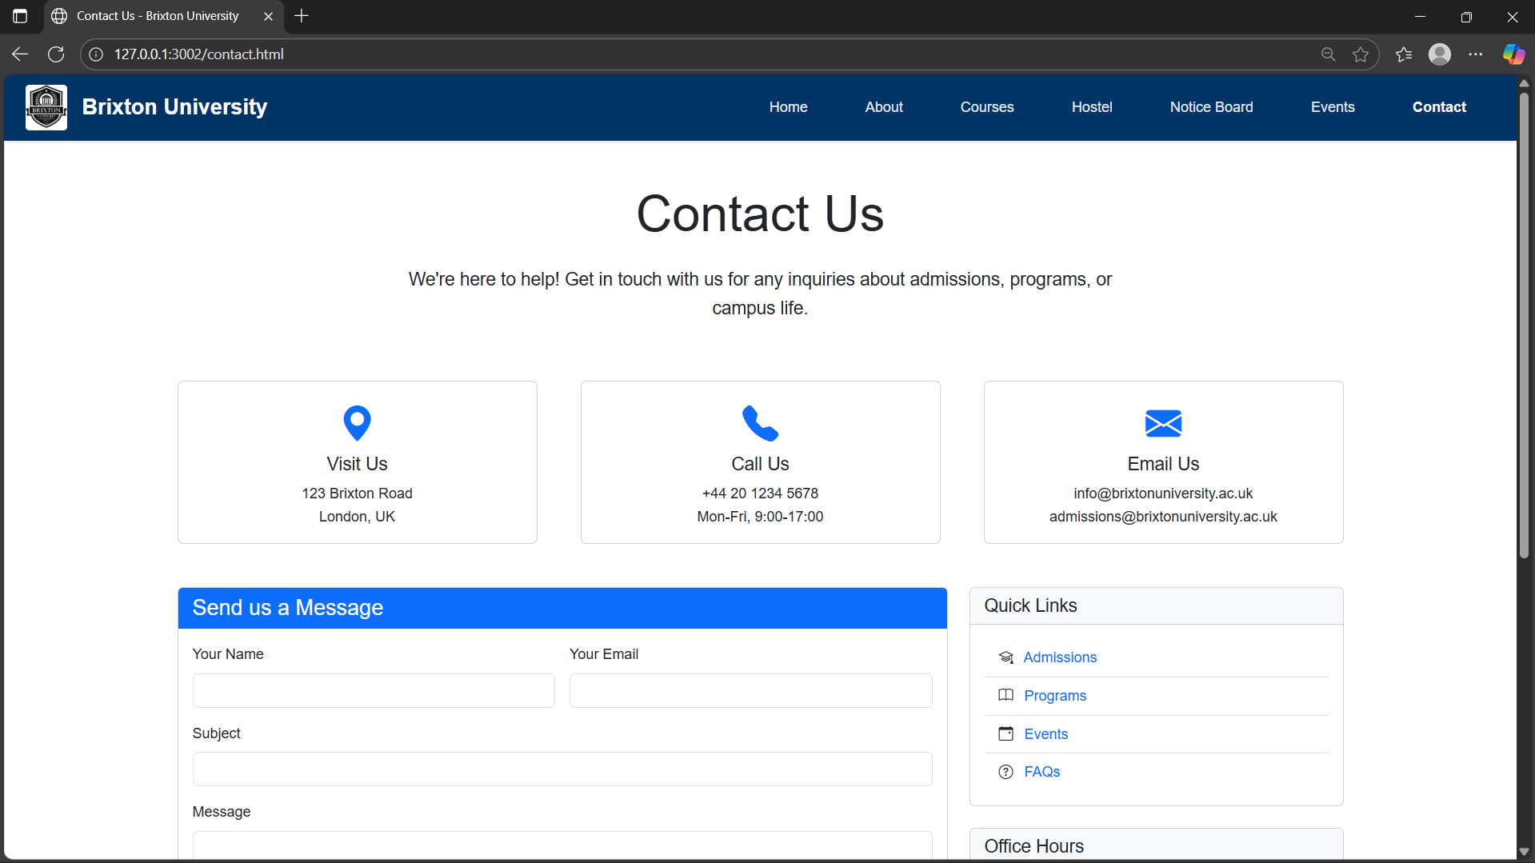

**14. Conclusion**

Developing the Brixton University website using modern web technologies including JavaScript, Bootstrap, and jQuery provided an invaluable learning experience in full-stack front-end development. This project significantly enhanced our understanding of responsive frameworks, interactive JavaScript programming, and component-based UI development.

The integration of Bootstrap streamlined our development process while maintaining high design standards and cross-browser compatibility. jQuery's powerful DOM manipulation capabilities allowed us to create smooth, engaging user interactions that elevate the overall user experience. Working with these technologies together taught us the importance of framework integration and modern development workflows.

The most rewarding aspect was successfully creating a fully interactive, professional website that demonstrates contemporary web development practices. The combination of Bootstrap's responsive foundation, custom JavaScript functionality, and jQuery animations resulted in a dynamic platform that could realistically serve a modern educational institution.

This project reinforced the critical importance of performance optimization, accessibility standards, and mobile-first design in modern web development. The experience has prepared us well for advanced front-end frameworks and full-stack development challenges.

**15. References**

* **L&T LMS:** https://learn.lntedutech.com/Landing/MyCourse - Primary course material and assignment guidelines
* **W3Schools:** Comprehensive reference for CSS Grid and Flexbox properties
* **MDN Web Docs:** Browser compatibility information and semantic HTML best practices
* **CSS-Tricks:** Advanced responsive design techniques and layout solutions
* **Google Fonts:** Typography selection for professional academic presentation
* **University Website Examples:** Research inspiration from Stanford, MIT, and Harvard websites